API Status Code

🌐 What is an API Status Code
# Source: AI Source: Provided by: [Data Path: Persons Table -> ID Column: 1, Name_En Column: Motasem Essam] -> From: [ChatGPT] on [1/19/2026]
API Status Codes are standard HTTP codes that indicate the result of a client’s request. They help the client understand whether the request succeeded, failed, or needs correction.
👉 Think of status codes as “signals” from the server about what happened with your request.

🔑 Categories of HTTP Status Codes
# Source: AI Source: Provided by: [Data Path: Persons Table -> ID Column: 1, Name_En Column: Motasem Essam] -> From: [ChatGPT] on [1/19/2026]
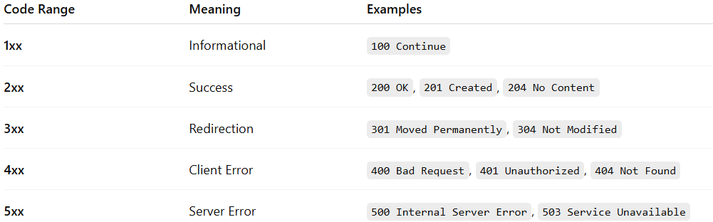
Code Range | Meaning | Examples
1xx | Informational | 100 Continue
2xx | Success | 200 OK, 201 Created, 204 No Content
3xx | Redirection | 301 Moved Permanently, 304 Not Modified
4xx | Client Error | 400 Bad Request, 401 Unauthorized, 404 Not Found
5xx | Server Error | 500 Internal Server Error, 503 Service Unavailable

🧱 Common API Status Codes
# Source: AI Source: Provided by: [Data Path: Persons Table -> ID Column: 1, Name_En Column: Motasem Essam] -> From: [ChatGPT] on [1/19/2026]
✅ Success
- 200 OK → Request succeeded, returning data
- 201 Created → Resource successfully created
- 204 No Content → Request succeeded, no data to return
⚠️ Client Errors
- 400 Bad Request → Invalid request or missing parameters
- 401 Unauthorized → Missing or invalid authentication
- 403 Forbidden → Client not allowed to access resource
- 404 Not Found → Resource does not exist
⚠️ Server Errors
- 500 Internal Server Error → Unexpected server error
- 503 Service Unavailable → Server temporarily unavailable

🧱 Example: User API
# Source: AI Source: Provided by: [Data Path: Persons Table -> ID Column: 1, Name_En Column: Motasem Essam] -> From: [ChatGPT] on [1/19/2026]
Request
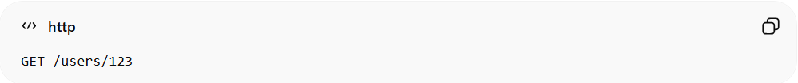
GET /users/123
Response 200 OK
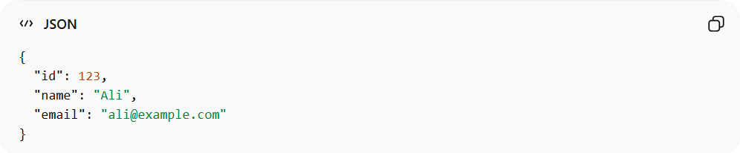
{
"id": 123,
"name": "Ali",
"email": "ali@example.com"
}
Response 404 Not Found
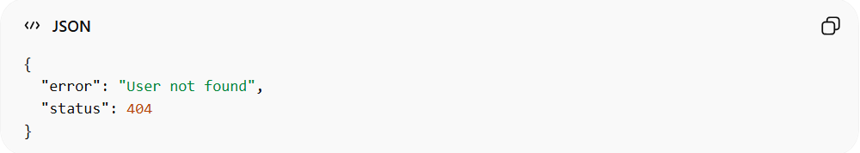
{
"error": "User not found",
"status": 404
}

✅ Best Practices
# Source: AI Source: Provided by: [Data Path: Persons Table -> ID Column: 1, Name_En Column: Motasem Essam] -> From: [ChatGPT] on [1/19/2026]
- Always use appropriate status codes
- Include meaningful messages in response body
- Avoid returning 200 OK for errors
- Follow consistent patterns across API endpoints

❌ Common Mistakes
# Source: AI Source: Provided by: [Data Path: Persons Table -> ID Column: 1, Name_En Column: Motasem Essam] -> From: [ChatGPT] on [1/19/2026]
- Returning 200 OK for failed operations ❌
- Using vague codes without explanation ❌
- Mixing 4xx and 5xx inconsistently ❌

💡 Summary
# Source: AI Source: Provided by: [Data Path: Persons Table -> ID Column: 1, Name_En Column: Motasem Essam] -> From: [ChatGPT] on [1/19/2026]
API Status Codes tell the client what happened with the request so the client can handle responses correctly.

